UHF All-In-One Reader
Specification

Product Model：CJ2503A
Date： 2016/07/24
Version Code： V1.0.0

1. Product Feature
- Using Impinj R2000 RF Platform
- IP66 protection, adapt to work outside all weather
- CPU:ARM9 platform, basic frequency is 400MHz
- Support ISO18000-6B/6C dual protocol
- Built-in Linux 2.6 operating system, support customer’s customized and extendable development
- Support variety of communication interfaces, like RJ-45/RS-232/RS-485/Wiegand etc
- Built-in 9dBi circular polarization antenna
- Support one external antenna to achieve one driving two devices set up
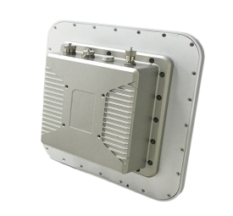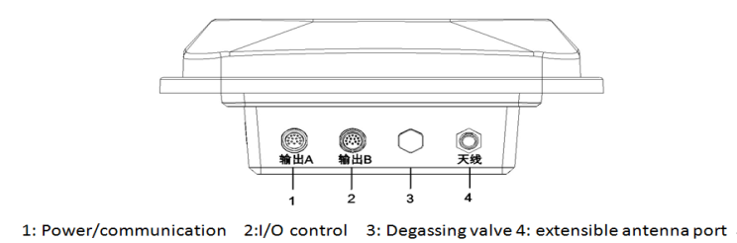
2. Product Introduction
CJ2503A is a high-performance UHF One-Piece Reader which integrated antenna and reader, and support ISO18000-6C/6B protocols. Its working frequency covers national standard dual frequency: 920MHz-925MHz, 840MHz-845MHz, FCC:902MHz-928MHz,ETSI:865MHz-868 MHz, and JP:916MHz-920MHz. Its output power is 0dBm-33dBm, and it has many good features, like long distance identification, fast speed, strong multi-label identification, strong anti-interference, high level protection and easy installing.
3. Typical Applications
- Intelligent vehicle management, like vehicle access control, ETC, Customs Clearance, Parking, Automatic Car Weighing Industry etc
- Automatic manufacturing, visual management etc
- Logistics Industry, like container management, pallet management
- Electronic Ticket, Card sender and Person Access control
- Asset warehousing management
4. Main Technical Specification
Physical Data
Size | 290mm×290mm×115mm
Weight | About 2.5kg(Not including accessory)
Shell material | Alloy+PC
Power | DC 24V/2.5A
Working Power consumption | 20W(Output Power 30dBm)
UHF RFID
Protocol | ISO18000-6B/6C
Frequency | GB :920～925MHz,840MHz～845MHz  FCC: 902～928MHz  ETSI: 865～868MHz  JP :916～920MHz （Optional）
Output Power | 0～33dBm(adjustable by software)
Power Regulation | 1dB Step
Spectrum bandwidth | ＜200kHz
Spectrum Stability | ≤±10ppm
External Interface | RJ-45，RS232，RS485, Wiegand
Operating Mode | Fixed Frequency or Frequency hopping mode
RJ-45 communication rate | 10M/100M self-adaptive
RS-232 interface | Baud Rate 115200bps(Default)
I/O | 2 relay output/ 2 optical coupler input
Reading speed | >400 time/s
Antenna | Built-in 9dBi circular polarization antenna, and support on external antenna
Reading distance | 0～10m (According to the label performance and using environment)
Writing distance | 0～5m (According to the label performance and using environment)
Working Environment
Working temperature | -30～+70°C
Storage temperature | -40～+85°C
Humidity | 10%～95% RH Without condensation
Support
Document | Demo，API，Developing guide

