UHF RFID Desktop Reader
Specification

Product model： CJ2502A
Date： 2016/06/27
Version code： V1.0.0

1. Feature
- Support ISO18000-6C protocol
- RJ-45/USB 2.0 Multiple communication interface support
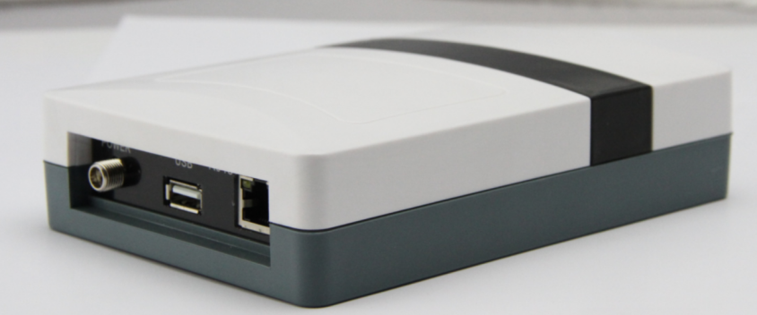
2. Specifications
CJ2502A desktop card reader with small shape, easy to carry, suitable for assembly line location management, entrance guard, books, document management, electronic tag reading and writing as well as the background, authorization, formatting, such as operation, can be read card, writing card format, authorization, etc.
- Typical application
- assembly line management
- Tag read/write, authorization, formatting, and normal operation
- electronic tickets, entrance guard card machine and personnel
- Management of assets and assets
4. Main technical performance index
physical parameter
Size | 160mm×110mm×35mm
Weight | 350g
canning material | ABS
Power | DC5V/4A
operating power | 1W
UHF RFID
protocol | ISO18000-6C
Frequency | GB: 920～925MHz
output power | 21dBm～28dBm(software can be adjustable)
power regulation | 1dB
external interface | RJ-45, USB2.0
operating mode | Fixed frequency or frequency-hopping mode
RJ-45 communication speed | 10M/100M self-adaption
Read speed | >100次/s
antenna | Internal Antenna
reading distance | 0～10cm (According to the label performance and the label working environment)
Written distance | 0～5cm ( According to the label performance and the label working environment )
work environment
Work temperature | -20～+55°C
storage temperature | -40～+85°C
humidity | 10%～95% RH
support
document | Demo software，API，Development guidance

